UNIVERSITY OF THE EAST

Rating
152 Samson Road, Caloocan City
College of Engineering
Information Technology Department

CCS2102 – OBJECT ORIENTED PROGRAMMING
Laboratory Activity 7

Name |  | Section:
Student Number |  | Professor: | Celis, J. R. E.

INSTRUCTIONS:
- For each problem, paste the code and sample output here.
- Make sure your name and student number are printed at the end of the output.

EXAMPLE:

Sample Problem:

Create a program that accepts two numbers, then displays the sum, difference, product, and quotient.

Code: Sample Output:
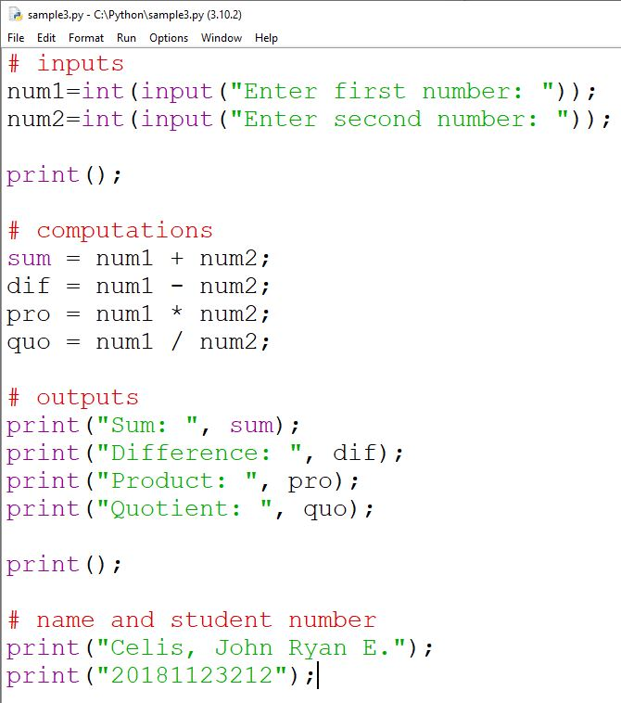
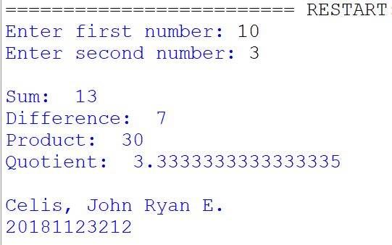

Problem:

- Modify the Function Overloading example in the lecture.
- Add another payment option called Credit Card.
- In this payment option the parameters are:
  - Amount to Pay
  - Payment Terms
- Display the “Amount to pay per Payment Term”.
  - Example: If the Amount to Pay is 15000 and the Payment Terms is 3, therefore the Amount to pay per Payment Term is 5000. That is 15000 divided by 3.
- Add this activity in your Journal.

